`

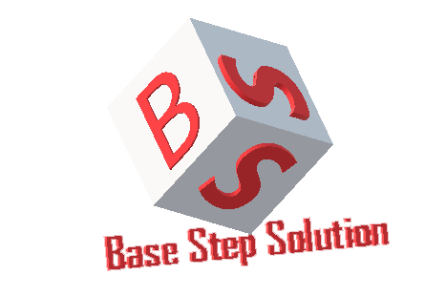

Meeting Minutes

Van Lang Admissions

# Revision Table

|  |  |  |  |
| --- | --- | --- | --- |
| **Author** | **Date** | **Reason for changes** | **Version** |
| Khoi Nguyen | 17/10/2017 | Initial Document | 1.0 |

Table of Contents

Revision Table 1

I. Purpose 3

II. Participant in meeting 3

III. Content of meeting 3

IV. To do task 4

|  |  |  |  |  |  |
| --- | --- | --- | --- | --- | --- |
| **Writer:** | Khởi Nguyễn | **Location:** | Campus 1 VLU | | |
| **Date:** | 17/10/2017 | **Start:** | 13h | **Finish:** | 15h |

# Purpose

Discuss about Capstone Project

Review requirement, schedule, technical

# participant in meeting

Mentor Lê Sĩ Phú

Team Capston:

* Nguyễn Thái Hiền
* Nguyễn Hoàng Anh Tài
* Đoàn Anh Minh
* Trần Xuân Hải
* Nguyễn Xuân Thái Hiền
* Nguyễn Anh Khởi

# Content of meeting

- Decide time and place of training

- Discuss about Front-end , back-end of topic

- Mentor advise to deal with customer about Meteor

- Mentor introduce about Nodejs , MongoDB

- Mentor advise to research about Database to apply MongoDB , AngularJS

# To do task

* Write Project Charter
* Write Master Plan
* Learn software development ( NodeJS , MongoDB , AngularJS … )

---- *** ----